## Changes to previous week:

## UI Prototype:

0.System displays initial select menu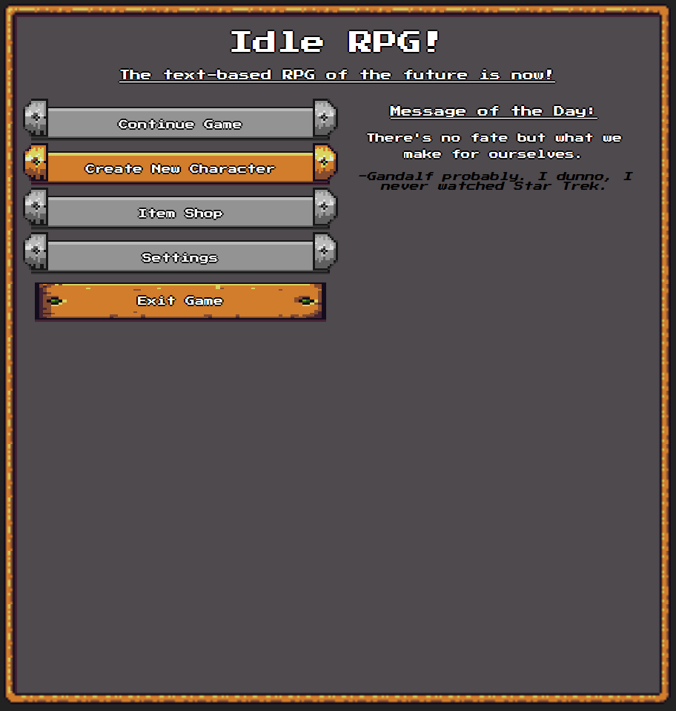

1. Player clicks Create New Character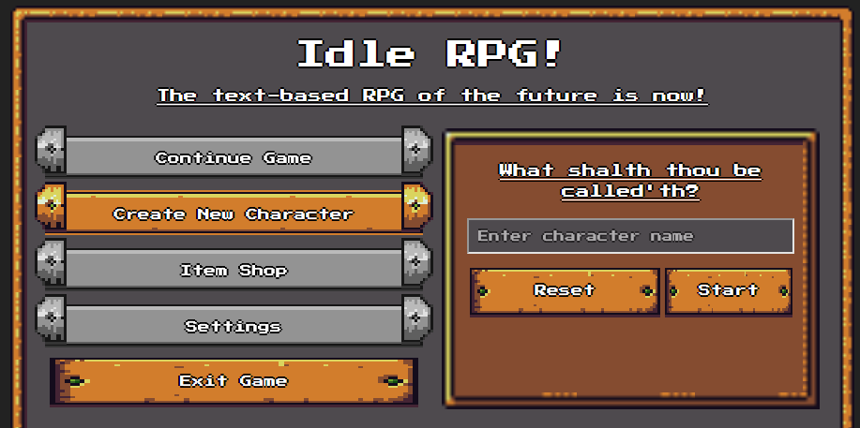

2. Player Enters character name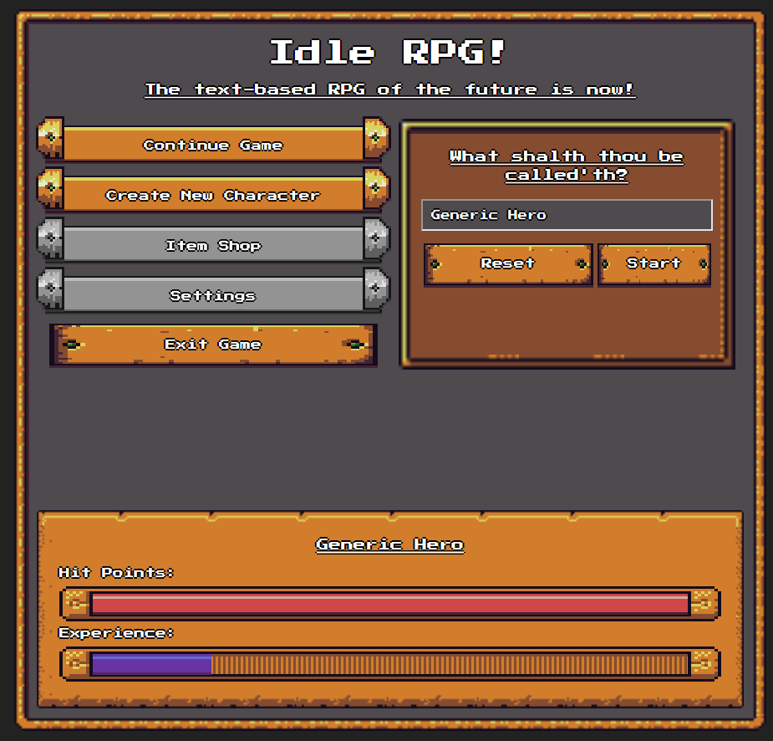

3. Player clicks start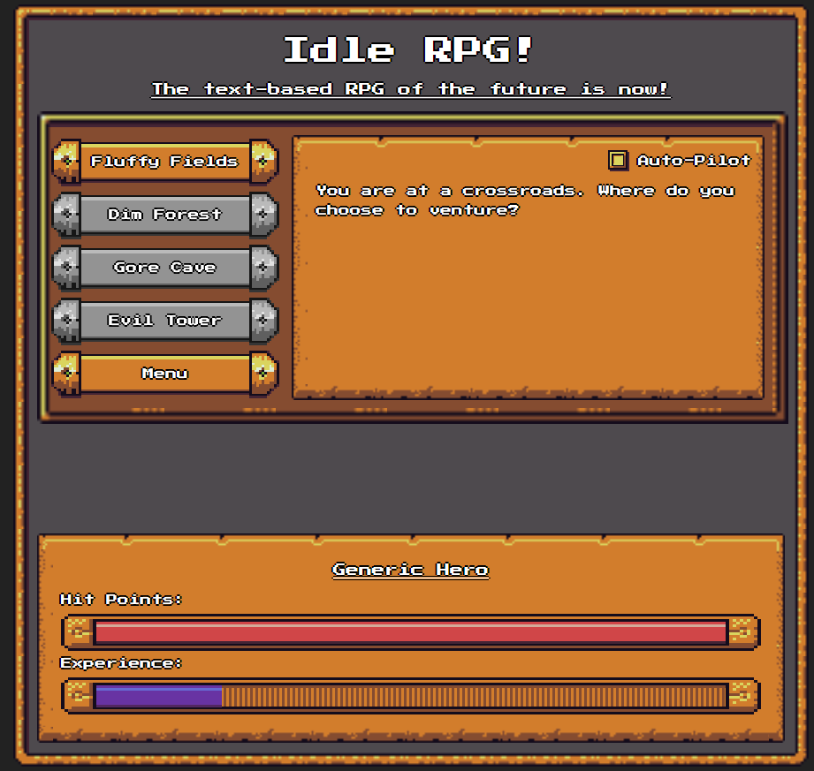

4. Player clicks Fluffy Fields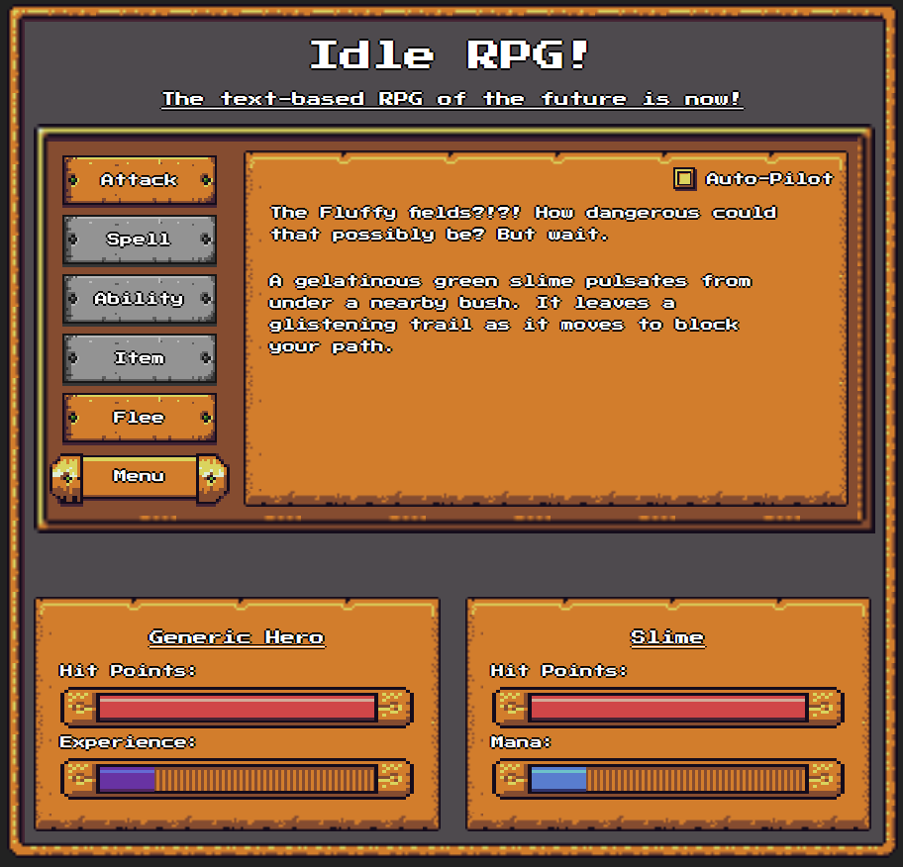

5. Player clicks Attack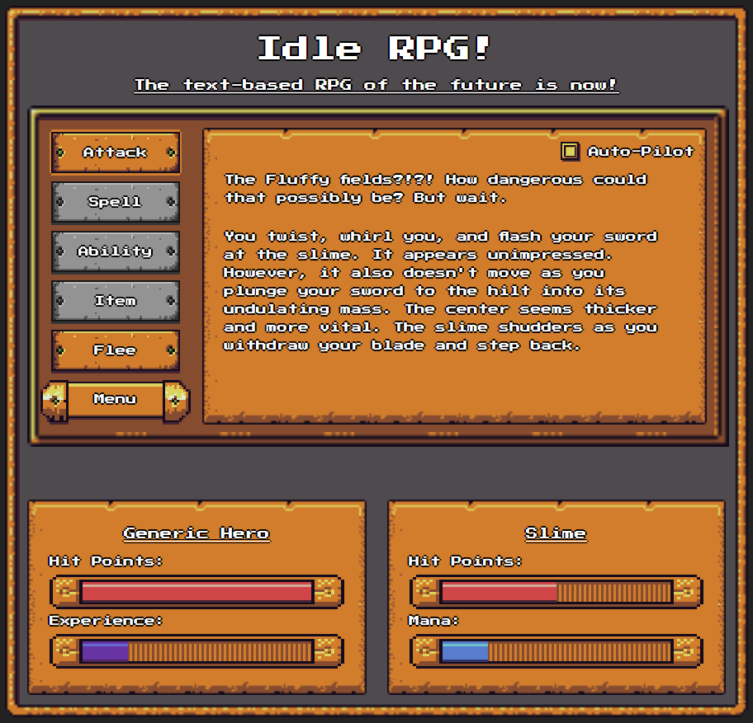

6. Slime counter attacks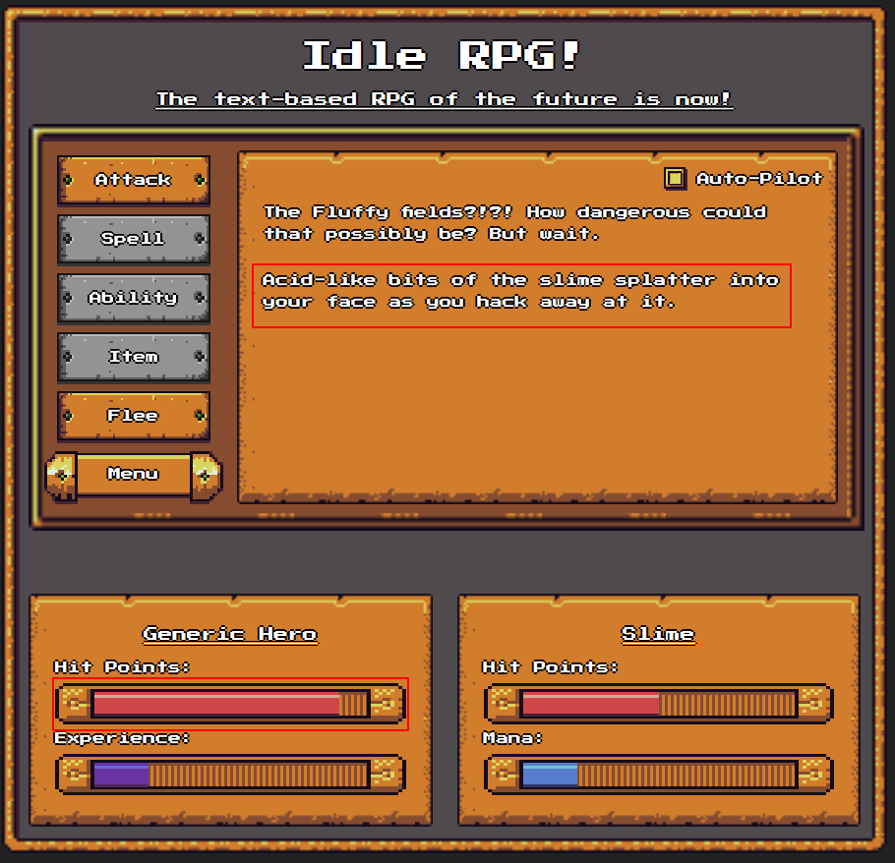

7. Player defeats slime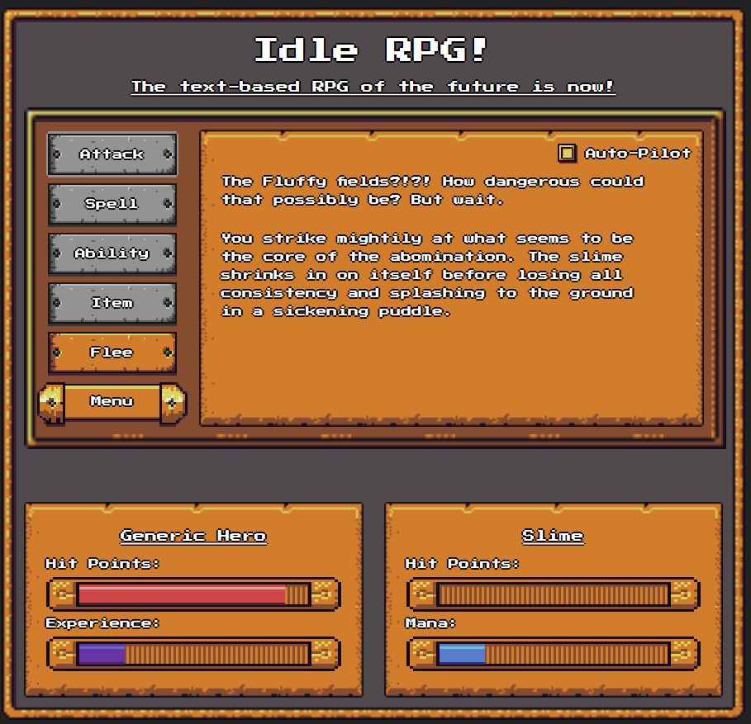

8. Player clicks Flee and succeeds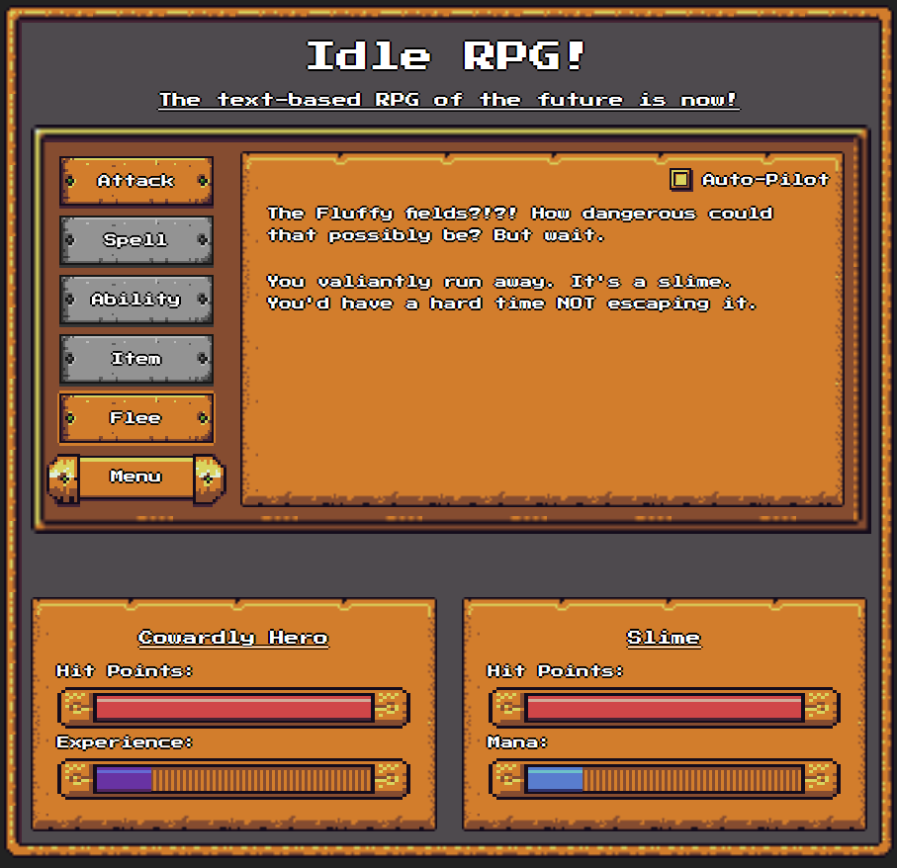

9. Program redirects Player to TravelScreen if Flee was successful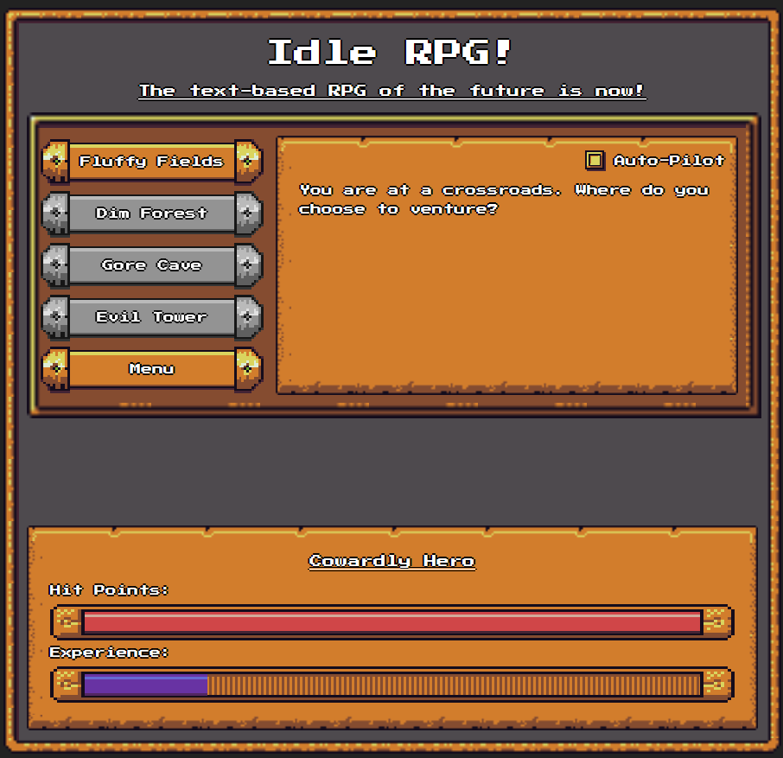

10. Player enables Auto-Pilot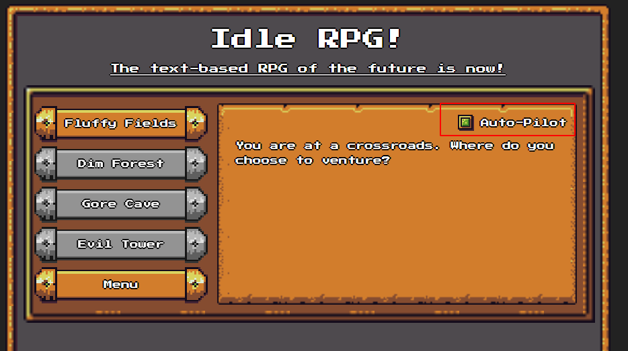

1. MVP Source Code: